1. **Install MongoDB database server**
2. **Create a directory/folder to store MongoDB datafiles**

**3. Set necessary path environment variable**

**4. Startup MongoDB database**

**5. Connect to MongoDB database through the MongoDB shell command line interface**

**6. View list of available databases**

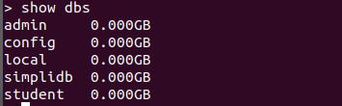

**7. Create a new database named CDAC and connect to it**



**8. View list of available collections in CDAC database**

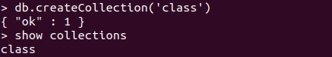

**9. Create a new collection by the name of LIBRARY**



**10. Insert the following document in the LIBRARY collection:-**

**title:'MongoDB programming', author:'Sameer', likes:100**



**11. View the recently inserted document and note the _id field**

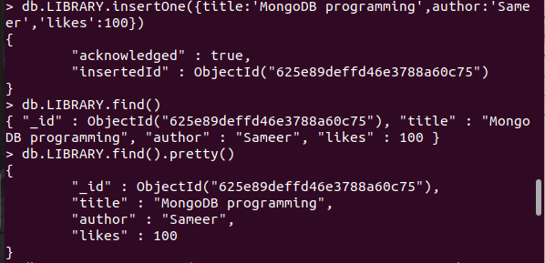

**12. Insert another document in the LIBRARY collection as follows:-**

**title:'MySQL programming', authors:['Jack','Jill'], likes:200**



**13. View the inserted documents**





**14. View only the first inserted document**

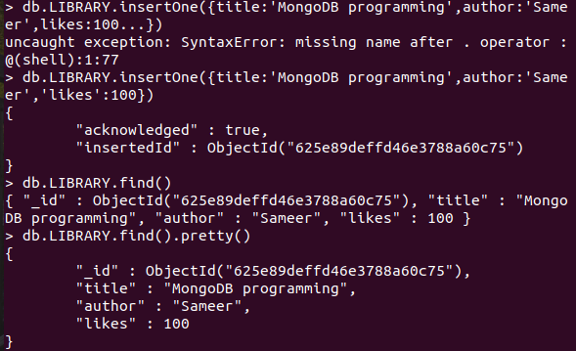

**15. View the documents using the pretty() method**

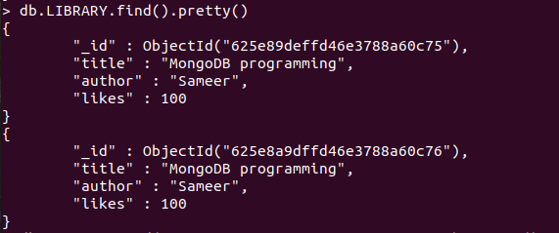

**16. Update the document where author name = Sameer and change it to Sameer Dehadrai**

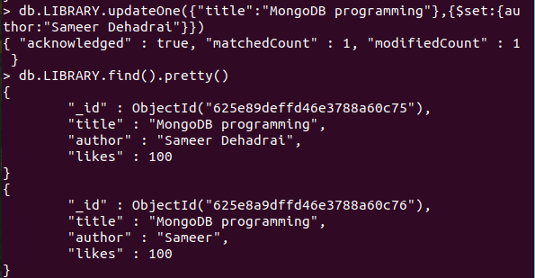

**17. Delete all documents that have 100 likes**

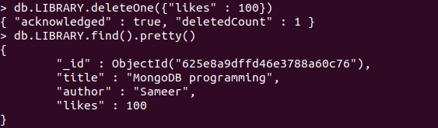

**18. Drop the LIBRARY collection**



**19. Drop the CDAC database**

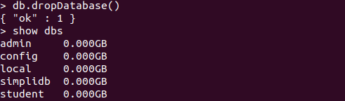

**20. Exit from MongoDB shell**

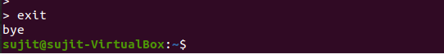

**21. Stop MongoDB server**